**Abenezer Namaga**

**Mel Raganit**

CPE 403 – 1001

CC1350 LAB 05

Github root directory: https://github.com/Ayertena/AdvEmbededSys

Date Due: November 24st, 2018

**Task 01**: Building and loading the collector example

* Successfully built and loaded the collector example on our CC1350.

----------------------------------------------------------------------

**Task 02**: Building and loading the sensor example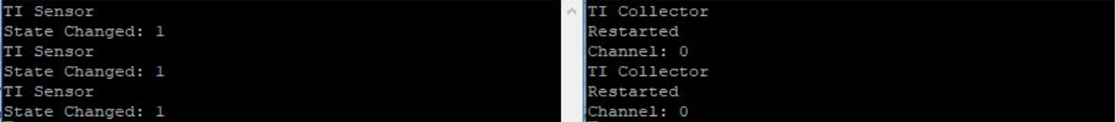

———————————————————————————————————

**Task 03**: Using the Collector and Sensor

* Implemented the two CC1350 devices with the collector/sensor examples and got them to interact with each other.

———————————————————————————————————

**Task 04**: Updating the sensor's reporting rate

* Changed the the reporting/polling interval for the collector example. We also changed the reporting interval for the sensor example then built and loaded the examples.

Youtube Link: https://www.youtube.com/watch?v=Fici4BQcRZQ